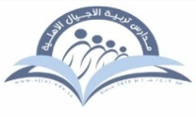
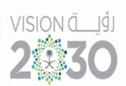

Kingdom of Saudi Arabia Tarbeat Al –Ajial International Schools
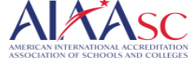
Ministry of Education American Section
Hafr Al Baten Directorate
2024/2025

Student’s name |  | Grade | 6
Subject | Computer | Week No. | 3
Lesson Title | Pictograms | 1st Semester Work sheet No. | 2
Instruction: Identify the meaning of the following signs

- 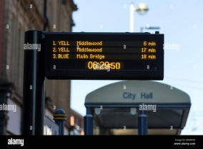 2. 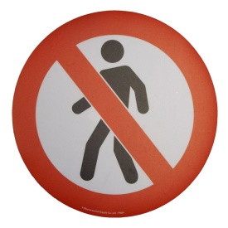

_____________________________ _____________________

3. 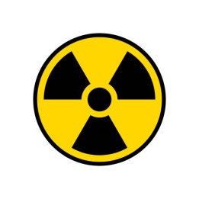 4. 
________________________ ______________________

5. 


